**Project Report Template**

1. **INTRODUCTION**

**1.1 Overview**

**An Recruiting app is a software application that helps organization manage their recruiting and hiring processes . It typically includes features such as job positing applicant tracking, resume management , and candidate communication.**

**I Developed this project using the website https://trailhead.salesforce.com/content/learn/projects/build-a-data-model-for -a-recuiting-app**

**2.2 Purpose**

**The Purpose of this Project is to provide customers with Self-Service registration for athletic facilities to improve customer access, reduce clerical personnel cost and improve facility utilization . Due to this customers easy to get opportunity and successfully registered for job posting .Also they know very well about this posting details.**

1. **Problem Definition & Design Thinking**
   1. **Empathy Map**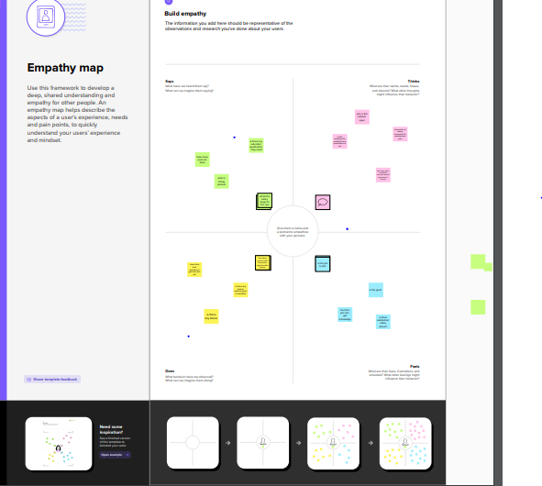
   2. **Ideation & brainstorming Map**

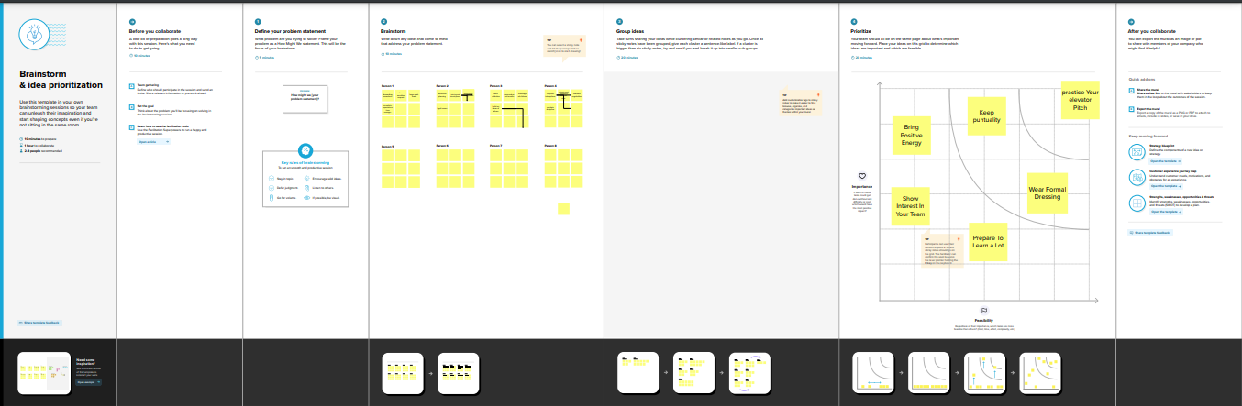

1. **RESULT**
   1. **Data Model**

**Object Name Fields in the Object**

**Field Label Data Type**

**Job posting site Text**

**Obj 1 Review Auto number**

**Field Label Data Type**

**Job posting site URL**

**Obj 2 Job posting master-detail**

**relationship**

**Obj 2**

**3.2 Activity& screenshot**

**DESCRIPTION:**

**Milestone 1:Developer account already created**

**Milestone 2:To launch the APP Launcher , then click playground starter ,click the install a package tab.**

**Paste 04t0P000000N9rs,click install, select install for admins only, once selected this it shown like done then click it to view the install package page.**

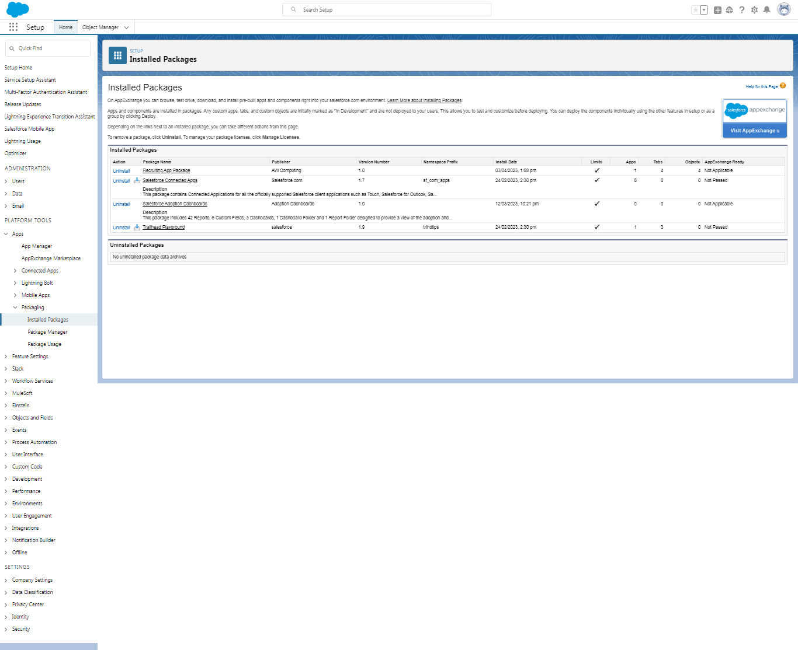

**Milestone 3:From object manager , click create, select object , give the label as job posting site**

**And record name as site name. select the data type as text .Then saved**

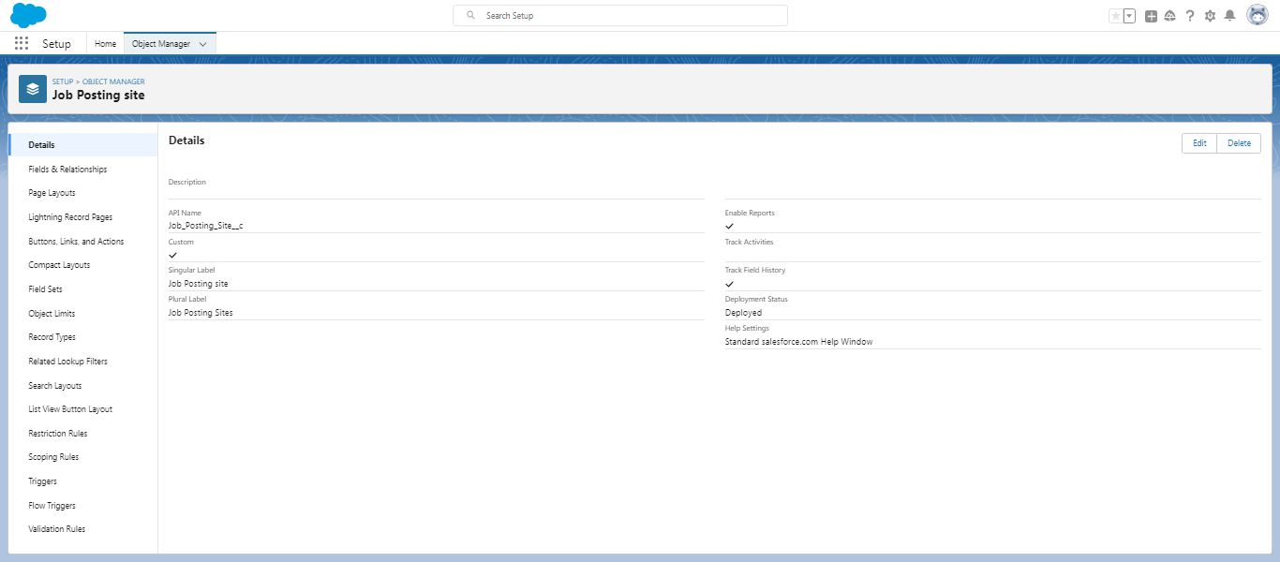

**Milestone 4:Tabs ,Select the tab style as a Real Estate. click next ,Leave the profile as is and click next**

**In the add to custom apps section ,Deselect include tab, select append tab to users existing personal customizations, click save.**

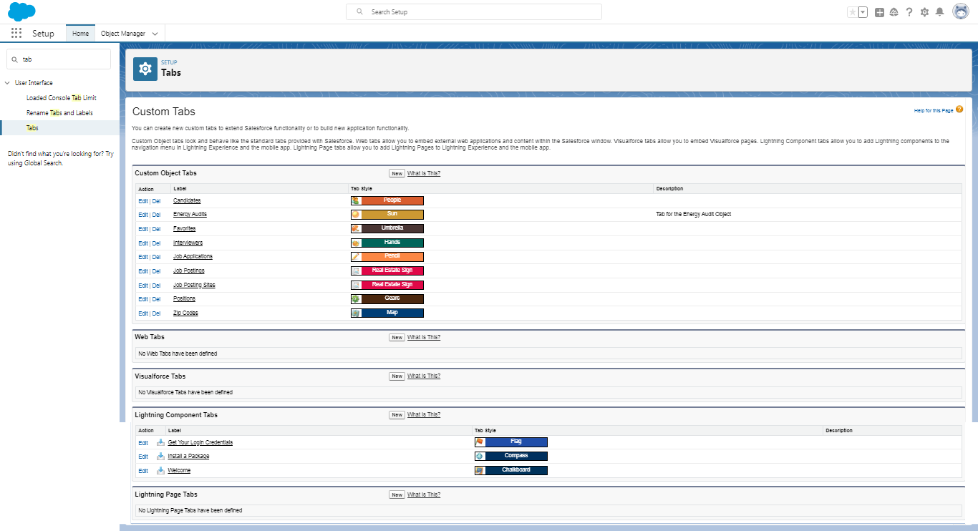

**Milestone 5:Fields From the object manager, click on the job posting site ,then click on the Fields & Relationship. Then click new, Here selected data type is URL, and field label as job posting site URL. Also here some of fields are created like status ,Technical site ,and Description.**

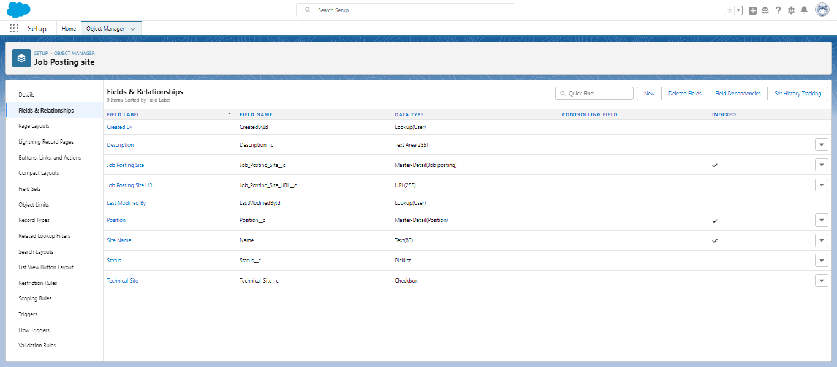

**Milestone 6: Junction object from object manager click create, select custom object.**

**Here label as Job posting ,and used data type is Auto number and display format. And the required details are saved.(Activity 1)**

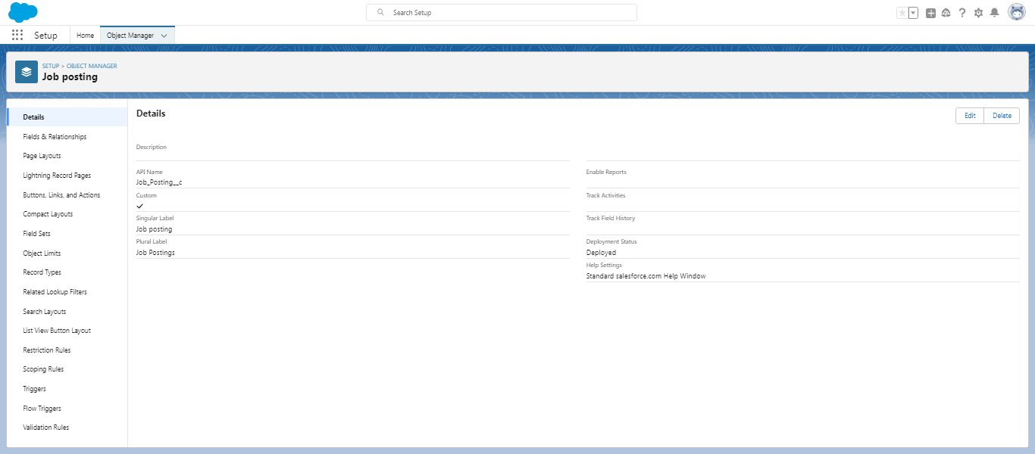

**(Activity 2): Relationship object ,From object manager go with job posting object the click Fields & Relationship. Here selected data type as Master-detail relationship this related to Job posting site and also position label is created using same way what would be follow in job posting site label and same data type have to be used and then saved.**

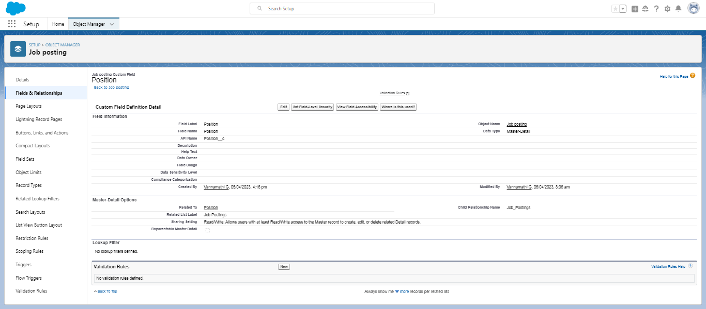

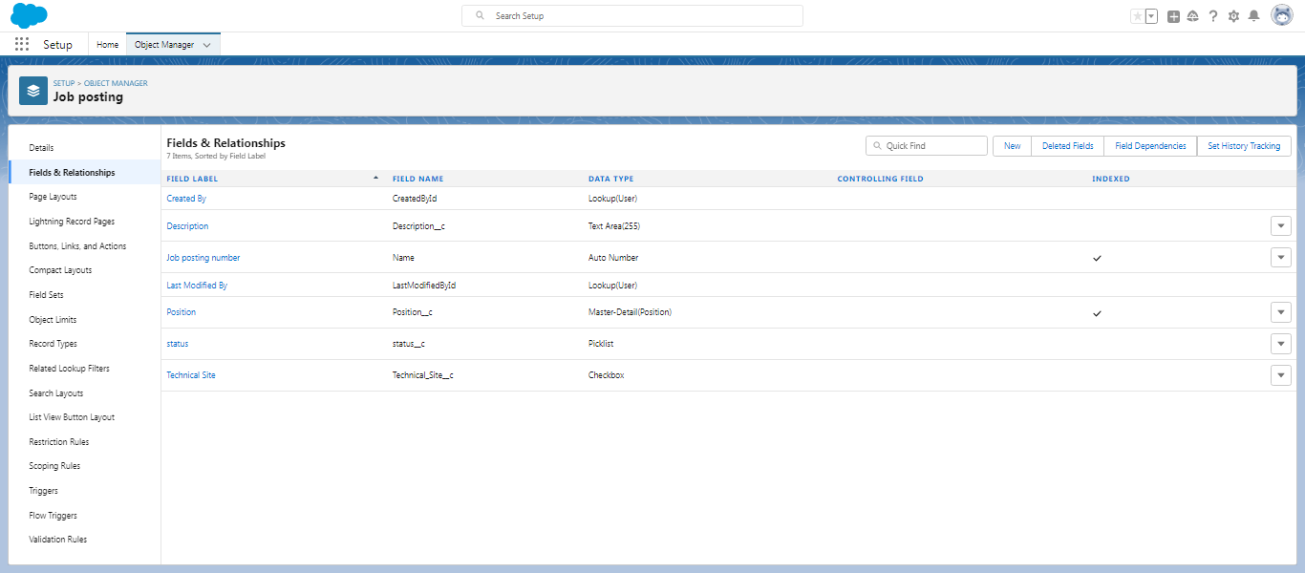

**Milestone 7:Page layout from object manager position option is clicked then go to page layout and select edit then find job posting related list ,from the available section select fields as status and Technical site ,then click add .Then job posting number option is removed from there .In same way create a page layout for review object object to do this we selected review object from object manager then go with page layout, then saved.**

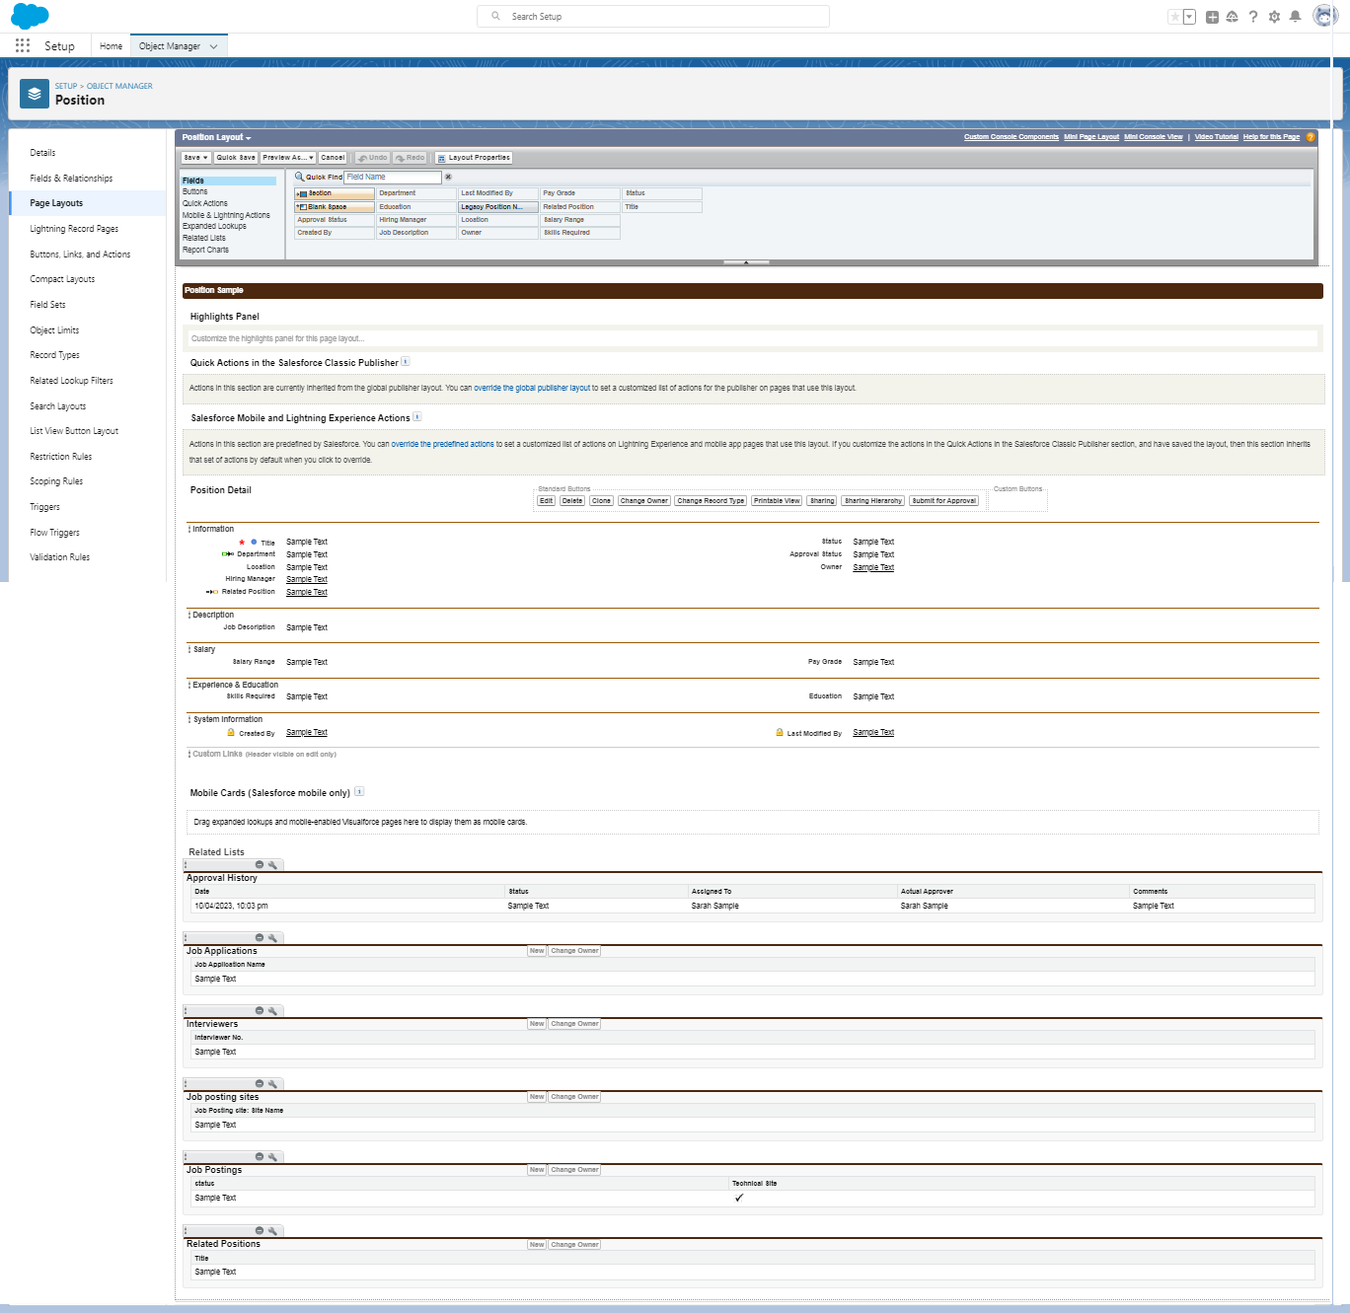

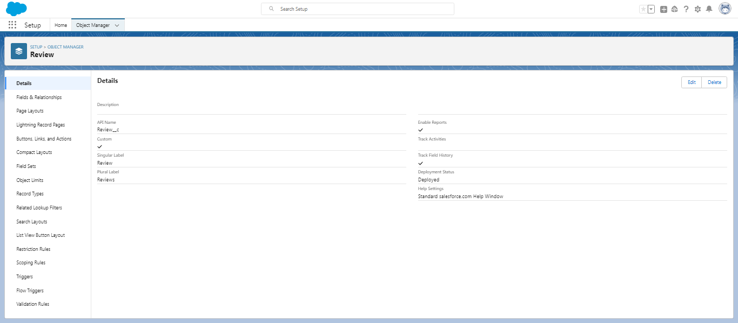

**Milestone 8:Validation rule ,from object manager ,position is selected then go with validation rule which is bottom of the required page then created field name as Every Position Have a Hiring Manager. Then selected location is Hiring Manager. Then error formula is given. If there is no error found in error formula proceed next step to save it .From here there is no error found in our error formula . Error formula used: ISBLANK (Hiring_ Manager __c) && $Profile. Name <> "System Administrator". Then saved.**

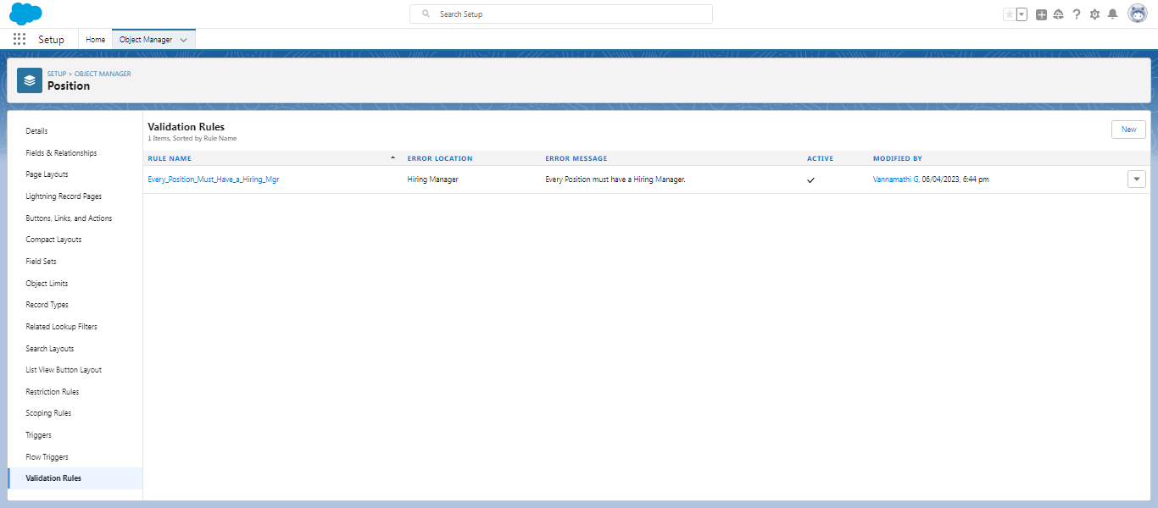

**Milestone 9:Profile ,from setup the profile option is selected and from the list sales profile is selected then go with clone and profile name is given as a sales profile then saved, also here profile has been created with the Free chatter profile name.**

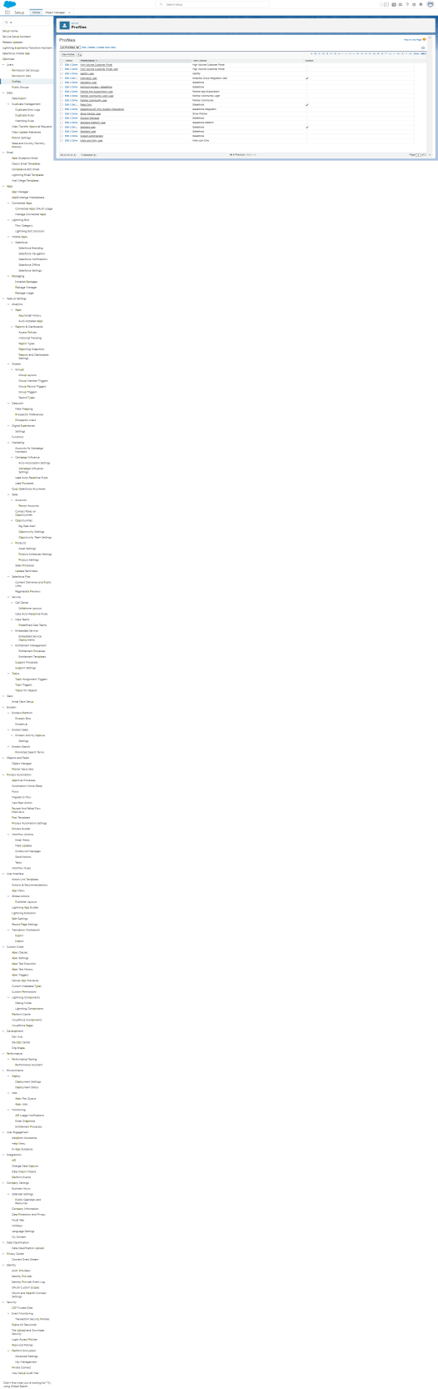

**Milestone 10:User ,from setup users option is selected the required details are entered like Name, Alias, Email, Username, Nickname, Role as default, User as salesforce and Profile as sales profile.**

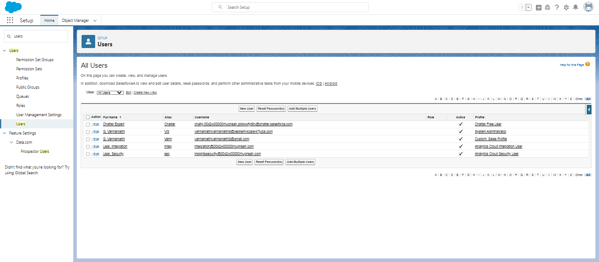

**Milestone 11:Permission set , from setup the permission sets option is selected then label name as supplier permits is given and saved .Once after saving this the manage assignment is clicked.After complete this the permission set foe review object is created.**

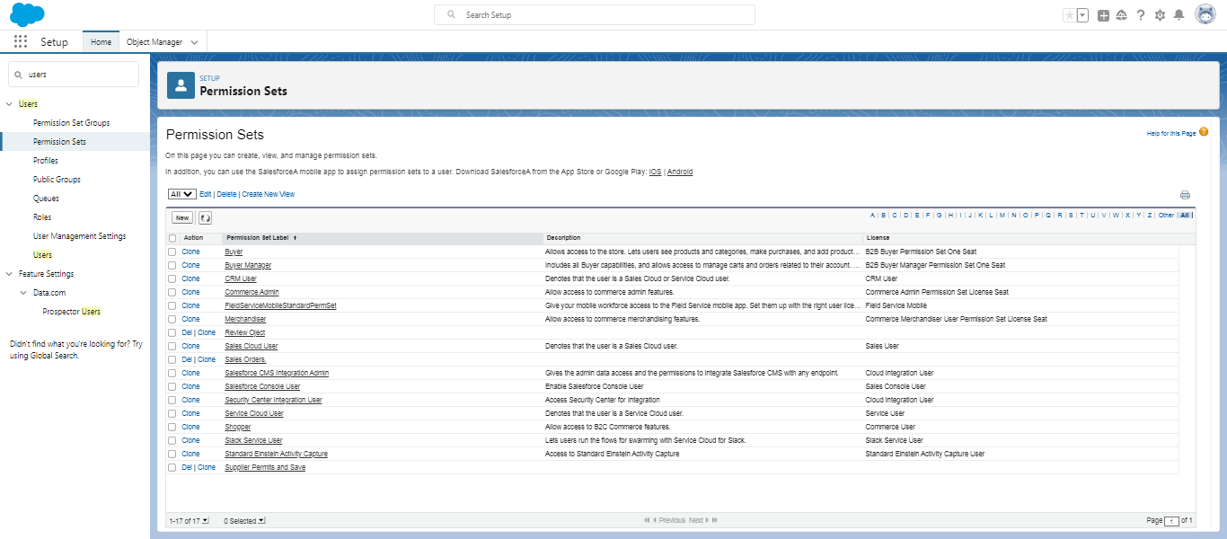

**Milestone 12:Reports ,from the app launcher to select sales option then go with Reports, and New reports are created and selected report type is Position then add some column and groups in it . And then saved. Here also report is created for Review and Job posting Objects.**

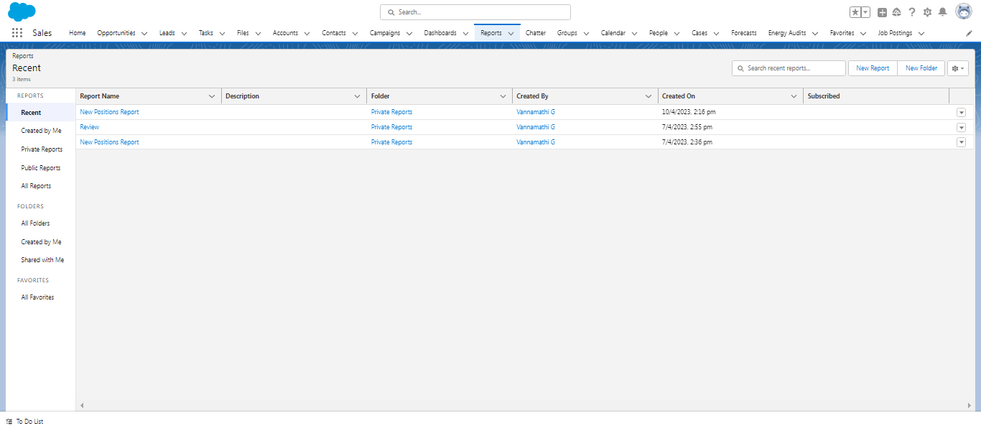

1. **Trailhead Profile Public URL**

**Team Lead- trailblazer.me/id/algan**

**Team Member 1-trailblazer.me/id/tjerry11**

**Team Member 2-trailblazer.me/id/tiniyan4**

**Team Member 3-trailblazer.me/id/gems-1**

1. **ADVANTAGES & DISADVANTAGE**

**Advantages:**

* **Recruitment plans make the hiring process smoother and out as a qualifying guidline for applicant.**
* **This helps employees to ensure that they are hiring individuals with the qualifications and skills needed to do the job.**
* **The biggest benefit is keeping the company on its course and running.**

**Disadvantage:**

* **The recruitment process saves lots of time, energy, and resources for the organization but also has some drawbacks. The most notable disadvantage of recruitment is that it leads to the stagnation of the work in the organization.**

1. **APPLICATIONS**

* **It can help to reduce how much time we use trying to find open jobs because part of their job duties is to search listings for us.**
* **There professionals establish working relationship with candidates , which help them understand which jobs to contact you about based on our qualifications.**

1. **CONCLUSION**

* **To fill a vacancy created in an organization it should be filled by a right person at right time at right cost .If recruitment and selection goes right the goal is achieved . Also it includes cost , so it should be done at predetermined cost.**
* **Recruitment is a process of searching for prospective employee and stimulating and encouraging them to apply for job in an organization.**

1. **FUTURE SCOPE**

* **Craft clear and attractive job ads.**
* **Boost our candidate sourcing.**
* **Build talent pipelines.**
* **Improve our recruitment efficiency.**
* **Evaluate candidates effentively.**
* **Enhance candidates experience .**